**Implementation of Resolve DNS**

**2.1. Prerequisite:**

1.DNS Server must be setup already.

## **2.2. Resolve DNS:**

## **How to use of Resolve DNS:**

1. Login to the TS server.

2. Open PowerShell as an administrator.

3. Resolve-DnsName -Name <Domaine_Name> -Server

<DNS_SERVER_IP> 2>C:/share/DNS_resolve/error_resolve_dns.log | Out-File C:/share/DNS_resolve/resolve_dns.log4. You will get DNS resolve result in resolve.log file

PATH -"C:/Share/DNS_resolve/resolve.log" .

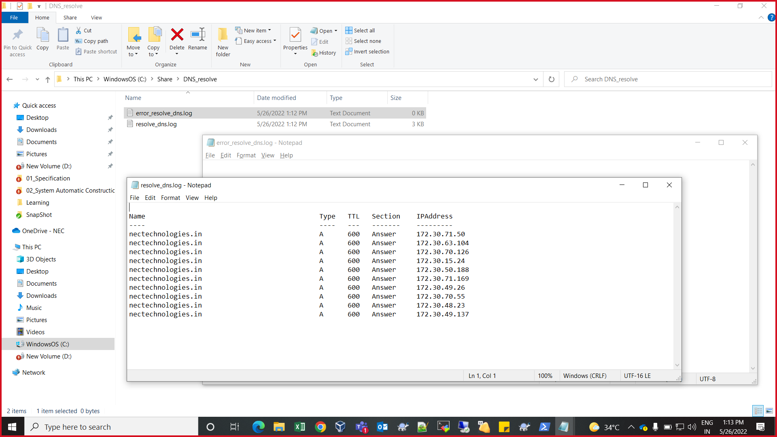

Fig. 2.1 DNS log file

## **Evidence:**

Local Execution with Evidence.

Below command executed on TS server

**Command:**

Resolve-DnsName -Name nectechnologies.in -Server 172.30.63.104 2>C:/share/DNS_resolve/error_resolve_dns.log | Out-File C:/share/DNS_resolve/resolve_dns.log

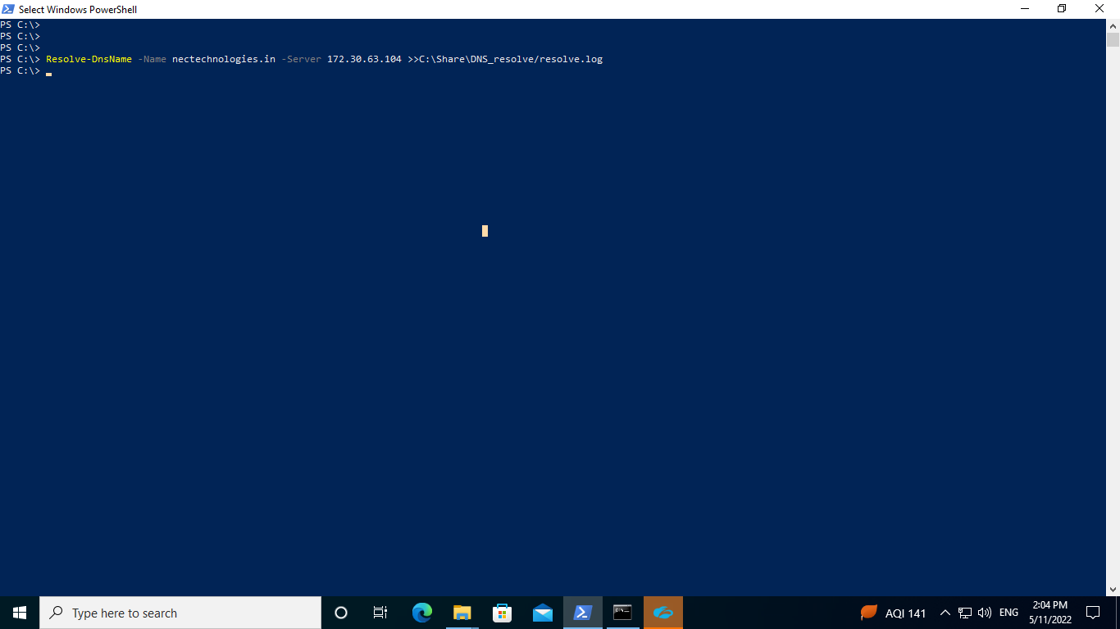

2.2. Executed Command on TS server

Remote Execution with Evidence

Below command executed on TS server

**Command:**

python

Python 2.7.5 (default, Jun 20 2019, 20:27:34)

[GCC 4.8.5 20150623 (Red Hat 4.8.5-36)] on linux2

Type "help", "copyright", "credits" or "license" for more information.

>>> import winrm

>>> s = winrm.Session('NTI-CASS-T-TS-1.nectechnologies.in:5985', auth=('CASSIOPEIA.Admin@NECTECHNOLOGIES.IN', 'C@SSIOPEI@!*3#t%m$'), transport='kerberos')

>>> r = s.run_ps('Resolve-DnsName -Name nectechnologies.in -Server 172.30.63.104 >>C:\Share\DNS_resolve/resolve.log')

>>> r.status_code

0

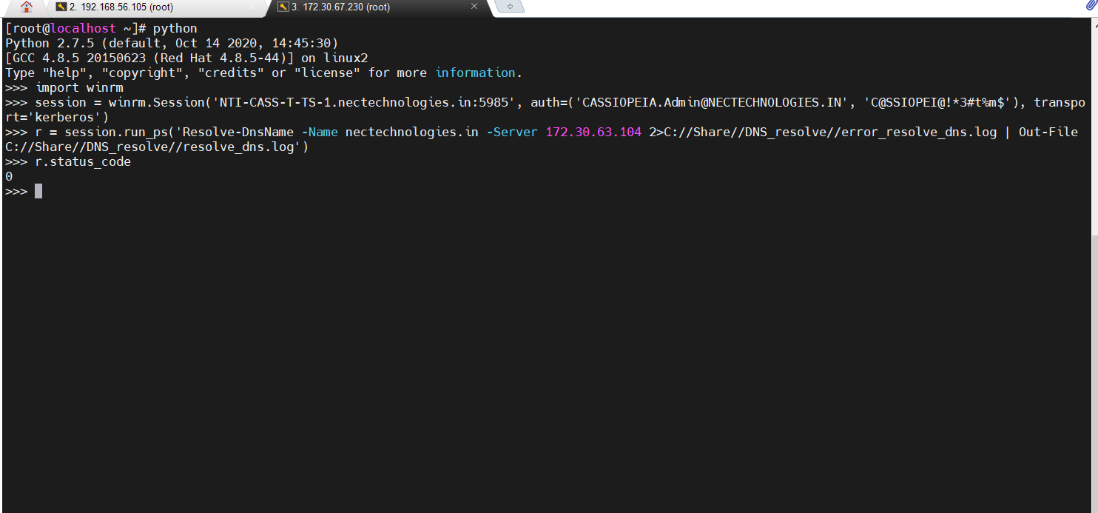

2.3. Remote Execution on TS Server Successful status evidence

## **Verification:**

**Verification:** Follow the below path:

1. Login to TS server.

2. Go into "C:/Share/DNS_resolve/"

3. resolve.log file must be there.



Fig. 2.4. DNS log file